***************************************************************************
Seventh Sunday After Epiphany
February 23, 2025
********************************************************************

PRELUDE "Cibell” Jean Baptiste Loeillet

WELCOME/JOYS AND CONCERNS

INTROIT Choir

CALL TO WORSHIP (Psalm 37)
L. Come, trust in the Lord and do good.
- We will trust in the Lord and find peace in his
ways.
- Delight in the Lord, and he will give you the desires
of your heart.
- We will commit our way to him and trust that he
will act.
- The Lord is our refuge, our strength, and our
salvation.
- In him, we find hope, for those who hope in the
Lord will inherit the earth.
- Let us worship the Lord with grateful hearts.
- We come to worship, trusting in his faithfulness
and love.

*INVOCATION

*OPENING HYMN "Lead Us, Heavenly Father, Lead Us" #344

SCRIPTURE READING Genesis 45:3-11, 15 Joseph made known to his brothers

CALL TO CONFESSION

CONFESSION Merciful God, like Joseph's brothers, we have sometimes turned away from those we should love and have acted in selfish ways. We confess that we have harbored resentments, allowed pride to guide our actions, and failed to see your hand at work in our lives. Forgive us for our brokenness and our broken relationships. Help us to reconcile, to forgive as we have been forgiven, and to live in the peace of your love, trusting that you work all things for good. In Jesus’ name, we pray. Amen.

WORDS OF ASSURANCE

CHORAL ANTHEM “Take Now My Voice" Douglas Nolan

INVITATION TO THE OFFERING
OFFERTOR "My Lord, What a Morning" Arr: Roger Wilson
DOXOLOGY Praise God from whom all blessings flow: Praise him all creatures here below; Praise him above, ye heavenly host: Praise Father, Son, and Holy Ghost. Amen.
*OFFERTORY PRAYER
HYMN “Be Thou My Vision" #391
SCRIPTURE: Luke 6:27-38
SERMON Pastor Adam

PRAYER/LORD'S PRAYER
Our Father, who art in heaven, Hallowed be thy name.
Thy kingdom come. Thy will be done on earth, as it is
in heaven. Give us this day our daily bread. And
forgive us our sins, as we forgive those who sin
against us. And lead us not into temptation, but
deliver us from evil: For Thine is the kingdom, and the
power, and the glory, for ever. Amen.

*CLOSING HYMN “Amazing Grace” (Insert)

BENEDICTION

POSTLUDE "Chaconne" Gordon Young

Pastor: Rev. Rick Miller
Guest Speaker: Rev. Adam Rohler
Organist and Choir Director: Ralph W. Farrar
Liturgist: Jerry Steves
Ushers: Gary Carnes and Carolee Corbitt
Scripture Reader: Kath Centi

Announcements
Worship Service at 10:45am
Thursday: Choir Practice at 7pm
Bible Study Thursdays at 1:00pm

Thank you for leading us again today, Adam.

UCAN still needs $5 Tim Horton gift cards to give to the people who use the City Mission. Remember, this is an ongoing project. Thank you to everyone who participates.

Please remember to bring in NEW Easter items for our basket for St. Susan Basket Fair. Time is going by quickly!
St. Susan Basket Fair will be held March 29 at Fluvanna Community Church from 11 to 3:00. Please bring in your items by Sunday, March 9.

Women’s Group after church.

There are signup sheets on the back table for cupcakes for dessert at our Spaghetti Dinner. There is also a work sheet for what you think you may be able to help with at the dinner.
We don’t have much time before our Spaghetti Dinner. Please get out there and sell your tickets to family, friends, and even strangers!!!

The United Church of Christ of Jamestown
70 McKinley Ave.
On Facebook at pilgrimfirstucc.
We extend a Jamestown, NY 14701
(716) 483-9665 Church Office
(716) 969-4826 Pastor’s Cell Phone
Our website is: www.pilgrimmeorialucc.org
Please join us warm welcome to our guests and visitors.

The People of the United Church of Christ in Jamestown
Welcome You

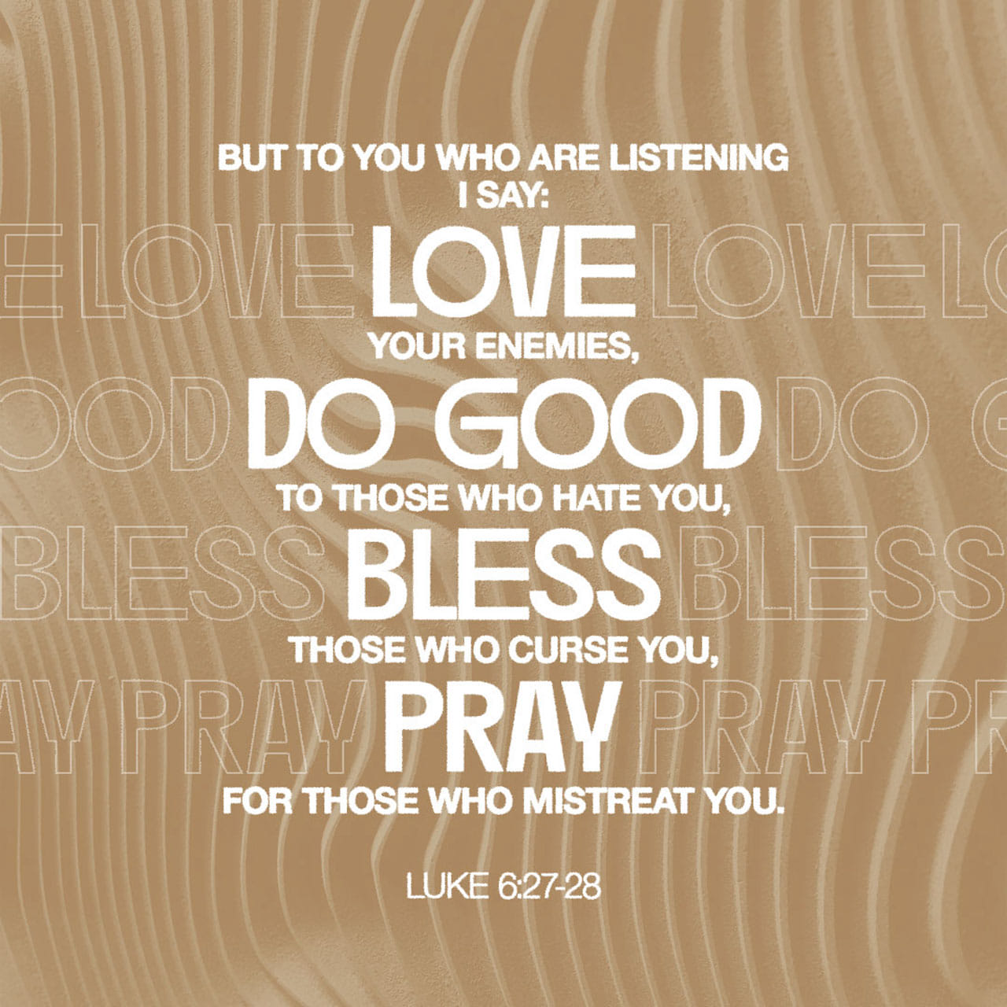

Ministers: Each one of us in the congregation made up of First Congregational Church and Pilgrim Memorial Church

