Twenty-Fifth Sunday After Pentecost
November 10, 2024

PRELUDE "Be Thou My Vision” Arr: Hal Hopson

WELCOME and ANNOUNCEMENTS

INTROIT Choir

CALL TO WORSHIP (Excerpts from “A Royal ‘Waste’ of Time," by Marva Dawn)
L: Worship is a cascade into the ever-flowing surprises of
encounters with the immensity of God’s magnificence
and sublimity and radiance.
C: Worship must be filled with all kinds of sounds,
new music and old, faithful fountains of praise, and
powerful retellings of the biblical narratives, an
ever-widening river to convey the grandeur of God.
L: Certainly if we were more immersed in God's splendor
we would find ourselves thoroughly "lost in wonder,
love and praise."
C: We worship Him extravagantly and, as a result, to
be his people more faithfully and to serve our
neighbors more lavishly.

*INVOCATION

*OPENING HYMN "Sing Praise to God Who Reigns Above” #20

SCRIPTURE Matthew 17:14-20 The Power of Faith

CALL TO CONFESSION

CONFESSION Heavenly Father, we come before you with humble hearts, acknowledging our struggles with faith and faithfulness. We confess that we have often doubted your promises, your presence, your provision, your protection, and your power. Help us to trust you fully and to live in the obedience of faith. Thank you that you are faithful, even when we are not. Amen.

CHORAL ANTHEM "Without Love It Will All Pass Away" Lloyd
Larson

INVITATION TO THE OFFERING
OFFERTORY “For the Beauty of the Earth” Arr: Charles Callahan
DOXOLOGY Praise God from whom all blessings flow: Praise him all creatures here below; Praise him above, ye heavenly host: Praise Father, Son, and Holy Ghost. Amen.
*OFFERTORY PRAYER
HYMN Lord I Want to Be a Christian" #353
SCRIPTURE Matthew 17:20
SERMON "Moving Mountains with Mustard Seed Faith”
Pastor Adam Rohler

PRAYER/LORD'S PRAYER
Our Father, who art in heaven, Hallowed be thy name.
Thy kingdom come. Thy will be done on earth, as it is
in heaven. Give us this day our daily bread. And
forgive us our sins, as we forgive those who sin
against us. And lead us not into temptation, but
deliver us from evil: For Thine is the kingdom, and the
power, and the glory, for ever. Amen.

*CLOSING HYMN “Holy Spirit, Truth Divine” #242

BENEDICTION

POSTLUDE "Largo on “Maori” Arr: Don Hustad

Pastor: Rev. Rick Miller
Speaker: Pastor Adam Rohler
Organist and Choir Director: Ralph W. Farrar
Liturgist: Jerry Steves
Ushers: Gary Carnes and Carolee Corbitt
Scripture Reader:

Announcements

Worship Service at 10:45am
Thursday: Bible Study 1:00pm
Thursday: Choir Practice at 7pm

Thank you, Adam, for joining us again today.

Please remember that we have food baskets behind the last pew for canned foods that you can bring in any time for the Food Pantry. Debbie Latona dropped off our last batch. Please do not put expired items in the baskets.

There is a basket on the back table for unused greeting cards for Meals on Wheels. This is an ongoing project.

Deacons and Trustees meet after church today.
Board Meeting and Coffee Hour after church next Sunday.

LOOKING AHEAD
Nov. 24 - Cake and coffee after church for Marie Schroeder’s 80th Birthday!
Nov. 24 – The Women’s Group meets after coffee hour for their Thanksgiving celebration. Remember your wrapped Bingo prizes, and those of you who signed up for favors, centerpiece, casseroles, dessert, beverage, and devotion see Peg if you’re not sure if you signed up for something!
Also November 24 is Stewardship Sunday. Please remember your next year’s pledge cards and the conference dues of $6, I think.

If you have sold your raffle tickets you can give them and the money to Peg.

The United Church of Christ of Jamestown
70 McKinley Ave.
Jamestown, NY 14701
(716) 483-9665 Church Office
(716) 969-4826 Pastor’s Cell Phone
Our website is: www.pilgrimmemorialucc.org
Please join us on Facebook at pilgrimfirstucc.
We extend a warm welcome to our guests and visitors.

The People of the United Church of Christ in Jamestown Welcome You

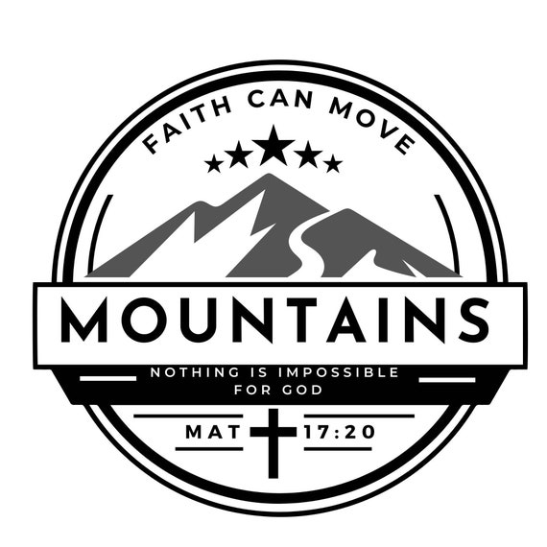

Ministers: Each one of us in the congregation made up of First Congregational Church and Pilgrim Memorial Church

