***************************************************************************
Third Sunday After Epiphany
January 26, 2025
********************************************************************

PRELUDE "The Wedding at Cana” John M. Rasley

WELCOME/JOYS AND CONCERNS

INTROIT Choir

CALL TO WORSHIP (Psalm 19)
- The heavens declare the glory of God;
The skies proclaim the work of his hands.
- Day after day they pour forth speech;
Night after night they reveal knowledge.
- There is no speech or language where their voice is not heard.
Their message goes out to the ends of the earth.
- The law of the LORD is perfect, reviving the soul;
The statutes of the LORD are trustworthy,
making wise the simple.
- Let the words of our mouths and the meditation of our hearts be pleasing in your sight, O Lord, our Rock and Redeemer.
- We come to worship you, our Creator and
Redeemer, whose glory fills the heavens and
whose Word revives our hearts. Amen.

*INVOCATION

*OPENING HYMN “Stand Up, Stand Up For Jesus" #385

SCRIPTURE READING 1 Corinthians 12:12-31a You are the body of Christ

INVITATION TO CONFESSION

CONFESSION OF SIN Lord, we confess that we have not always honored the diversity of your body, the Church. We have neglected to value each member, and the gifts you’ve given to all. Forgive us for our divisions, our pride, and our disregard for others. Help us to live in unity, to serve one another with humility, and to be Christ for the world. Amen.

WORDS OF ASSURANCE

CHORAL ANTHEM “A Morning Prayer” Benjamin Harlan

INVITATION TO THE OFFERING
OFFERTORY “Garden of Gathsemane" Scott Davenport
DOXOLOGY Praise God from whom all blessings flow: Praise him all creatures here below; Praise him above, ye heavenly host: Praise Father, Son, and Holy Ghost. Amen.
*OFFERTORY PRAYER
HYMN "What a Friend We Have in Jesus” #335
SCRIPTURE: Luke 4:14-21
SERMON “The Eyes Were On Him" Doug Hearn

PRAYER/LORD'S PRAYER
Our Father, who art in heaven, Hallowed be thy name.
Thy kingdom come. Thy will be done on earth, as it is
in heaven. Give us this day our daily bread. And
forgive us our sins, as we forgive those who sin
against us. And lead us not into temptation, but
deliver us from evil: For Thine is the kingdom, and the
power, and the glory, for ever. Amen.

*CLOSING HYMN “Onward, Christian Soldiers” #382

BENEDICTION

POSTLUDE “On the Road to Emmaus” John M. Rasley

Pastor: Rev. Rick Miller
Speaker Doug Hearn
Organist and Choir Director: Ralph W. Farrar
Liturgist: Jerry Steves
Ushers: Gary Carnes and Carolee Corbitt
Scripture Reader:

Announcements

Worship Service at 10:45am
Thursdays: Bible Study 1:00pm
Thursday: Choir Practice at 7pm

Thank you, Doug, for leading us two weeks in a row!!

UCAN needs $5 Tim Horton gift cards to give to the people who use the City Mission. This will be a continued project throughout the year.

Remember your nonperishable food items for the baskets in the back of the church.

Please stay after church for our Installation of Officers Coffee Hour.

The United Church of Christ of Jamestown
70 McKinley Ave.
on Facebook at pilgrimfirstucc.
We extend a Jamestown, NY 14701
(716) 483-9665 Church Office
(716) 969-4826 Pastor’s Cell Phone
Our website is: www.pilgrimmeorialucc.org
Please join us warm welcome to our guests and visitors.

The People of the United Church of Christ in Jamestown
Welcome You

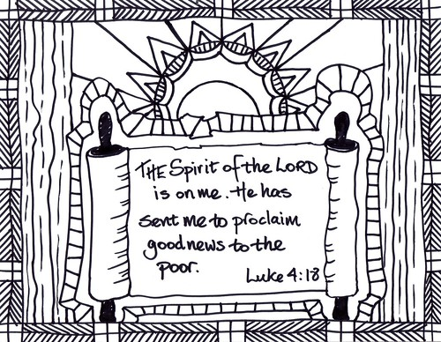

Ministers: Each one of us in the congregation made up of First Congregational Church and Pilgrim Memorial Church

